Algebra 1: Unit 6, Lesson 1

- A number line is shown with a solution to an inequality.
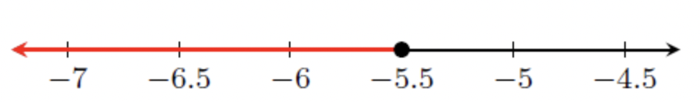
Write an inequality that represents the solution shown on the number line.

$$x≤-5.5$$

- Write the inequality for the phrase.
$y$ is at least $8$.

$$y≥8$$

- An inequality is shown.
$$-3.63z-5.2453≥15.7361$$What is the solution to the inequality?

$$z≤-5.78$$

